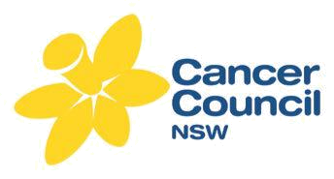
ITALIAN LANGUAGE RESOURCES ORDER FORM

Date: |  | Title: |  |  | First name: |  | Last name:
Position: |  |  |  |  | Organisation:
Delivery address: |  |  |  |  |  | Suburb: |  | State: |  | Postcode:
Phone: |  |  |  | Fax: |  | Email:
How will the resources be used?
Date Order Required:
Please allow 7 days for delivery (Australia Post). Do you need it sooner? (tick) |  |  |  |  |  |  |  | No | Yes

PLEASE NOTE: There is a limit of 10 fact sheets, per language & per topic.

CAN NUMBER | TITLE | TOTAL
 | Fact Sheets
CAN10203I 11/12 | Stop Smoking
CAN10204I 11/12 | Coping with a cancer diagnosis
CAN10205I 11/12 | Understanding Chemotherapy
CAN4469I MAR 14 | Understanding Cancer Surgery
CAN10206I 11/12 | Questions to ask your doctor
CAN10207I 11/12 | Complementary therapies & cancer
CAN4467I MAR 14 | Understanding Brain Tumours
CAN10210I 11/12 | Early detection of Ovarian Cancer
CAN10212I 11/12 | Early detection of Bowel Cancer
CAN10213I 11/12 | After a diagnosis of Prostate Cancer
CAN102141 11/12 | After a diagnosis of Breast Cancer
CAN4468I MAR 14 | After a diagnosis of Cervical Cancer
CAN10215I 11/12 | After a diagnosis of Ovarian Cancer
CAN10217I 11/12 | After a diagnosis of Bowel Cancer
CAN10218I 11/12 | Eat for Health
CAN10222I 11/12 | Stay in Shape
CAN10224I 11/12 | Move your body
CAN10225I 11/12 | Understanding Radiation Therapy
 | TOTAL

Please send the completed form by fax: (02) 8302 3506 OR by email: publications@nswcc.org.au

Cancer Council NSW, PO Box 572, Kings Cross NSW 1340 Phone: (02) 9334 1836

