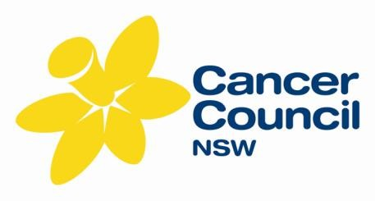ARABIC LANGUAGE RESOURCES
ORDER FORM

Date: | Title: |  |  | First name: |  | Last name:
Position: |  |  |  | Organisation:
Delivery address: |  |  |  |  | Suburb: |  | State: | Postcode:
Phone: |  |  | Fax: |  | Email:
How will the resources be used?
Please allow 7 days for delivery (Australia Post). Do you need it sooner? (tick) No Yes

PLEASE NOTE: There is a limit of 10 fact sheets, per language & per topic.

CAN NUMBER | TITLE  Fact Sheets | TOTAL
CAN10101A 11/12 | Stop Smoking
CAN10103A 11/12 | Coping with a Cancer Diagnosis
CAN10104A 11/12 | Understanding Chemotherapy
CAN10105A 11/12 | Questions to ask your doctor
CAN10106A 11/12 | Complementary Therapies and Cancer
CAN10110A 11/12 | Early detection of Ovarian Cancer
CAN10115A 11/12 | After a diagnosis of Prostate Cancer
CAN10116A 11/12 | After a diagnosis of Breast Cancer
CAN10117A 11/12 | After a diagnosis of Ovarian Cancer
CAN10118A 11/12 | After a diagnosis of Bowel Cancer
CAN10119A 11/12 | Eat for Health
CAN10123A 11/12 | Stay in Shape
CAN10125A 11/12 | Move your body
CAN10126A 11/12 | Understanding Radiation Therapy
CAN4469A 03/14 | Understanding Cancer Surgery
 | DVDs
3019A | DVD - Pancreatic Cancer: You are not alone (Arabic)
 | TOTAL

Please send the completed form by fax: (02) 8302 3506 OR by email: publications@nswcc.org.au
Cancer Council NSW, PO Box 572, Kings Cross NSW 1340 Phone: (02) 9334 1836 Fax: (02) 8302 3506

